MINISTRY OF EDUCATION AND SCIENCE OF UKRAINE

NATIONAL TECHNICAL UNIVERSITY

«KHARKIV POLYTECHNIC INSTITUTE»

Department of Software Engineering and Management Information Technologies

Report from lab № 7

discipline «Fundamental of Databases»

Completed by: **CHUKWU IRELE**

student of group: **1.KH201.8ei**

Checked by**: Assistant Polovinka O.L.**

Kharkov – 2019

**TOPIC :**LEARN DBMS ACCESS REPORT DEVELOPMENT TOOLS

**Goal:** State the laboratory practice problem. Study how to INCLUDE CHARTS AND DIAGRAMS INTO REPORTS USING DBMS ACCESS TOOLS

**Create a pivot chart**

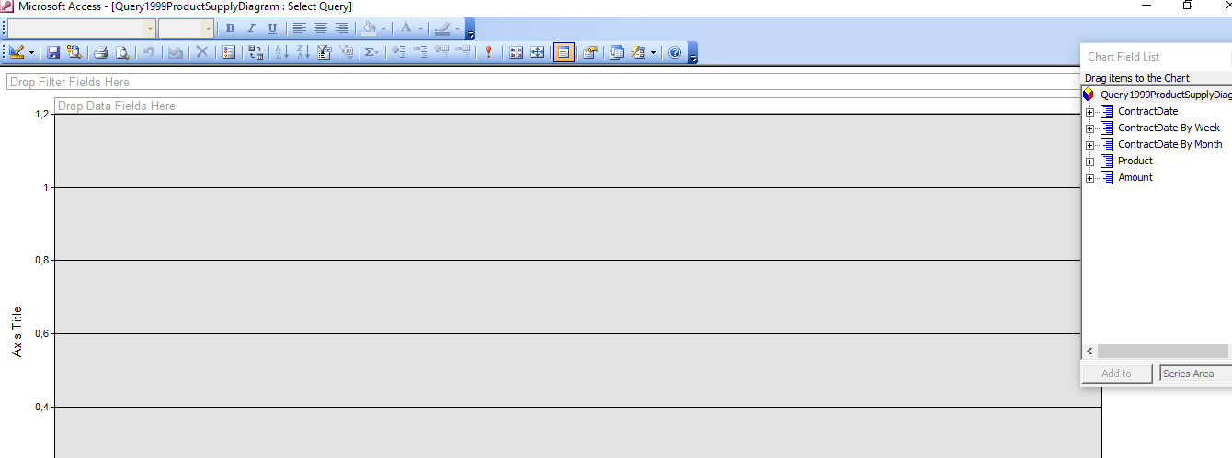

**Setup a diagram structure**

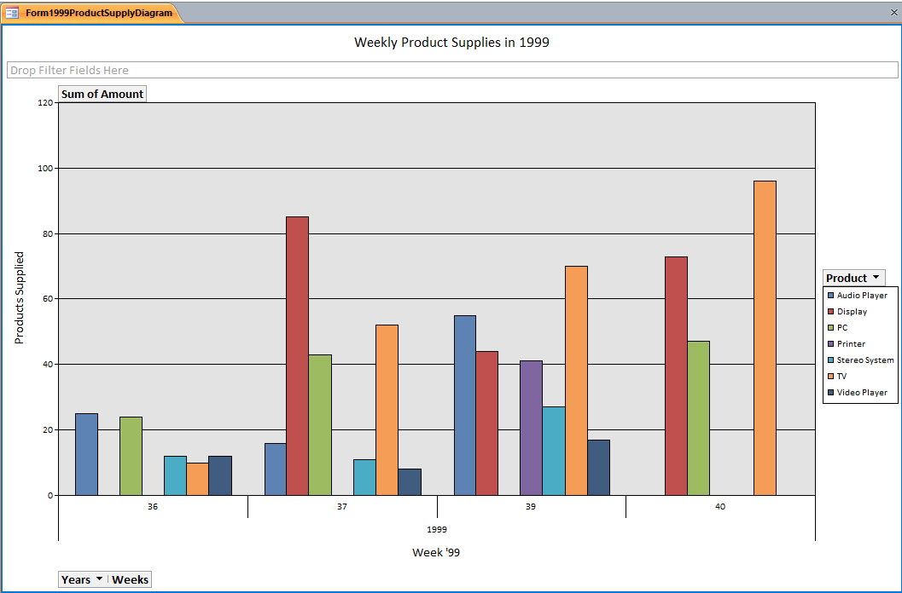

**Change chart type**

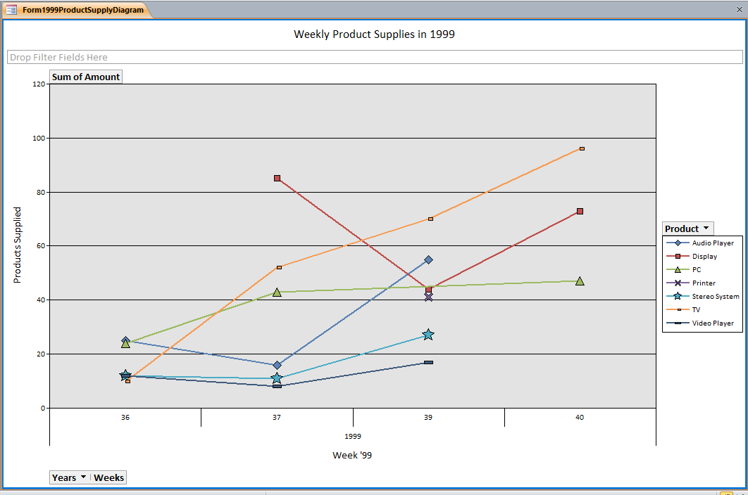

**Print charts in reports**

**Create a bonded chart based on a crosstab**

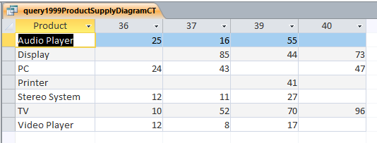

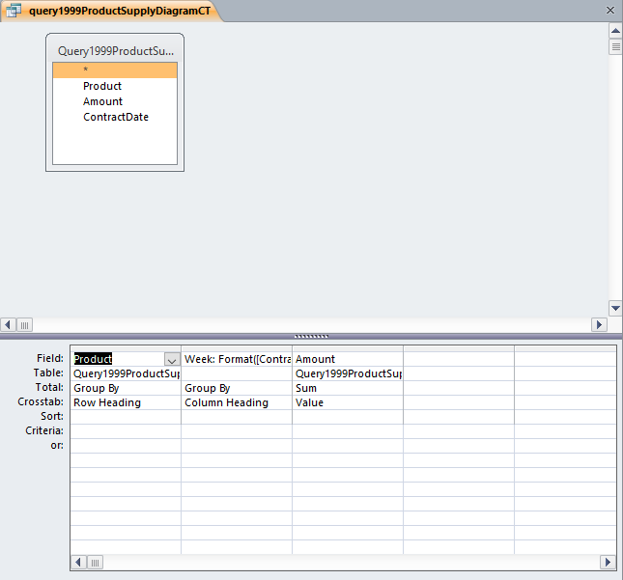

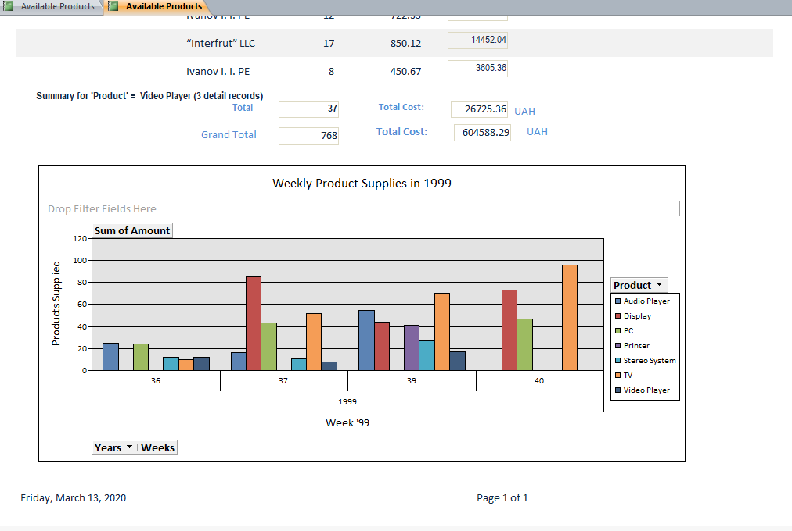

**Bound chart to the single query or table entry**

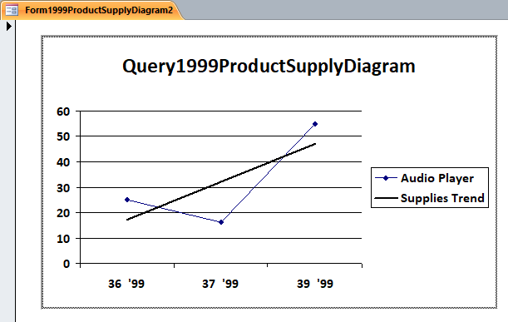 **Conclusion :**

At that lab were received knowledge about CHARTS AND DIAGRAMS INTO REPORTS USING DBMS ACCESS TOOLS, it`s usage and gotten practical skills that allows To create PIVOT CHARTS and create reports with these charts in the Access window using DBMS Access in this environment.